Energy Efficient Routing in Wireless Sensor Networks
Chetan Simikore, Chakrapani Saralaya, Prasad Patil, Prasad Bagewadi
Guide: Prof. N. S Sirdeshpande
Dept.of Electronics and Communication Engg., Gogte Institute of Technology
Visveswaraya Technological University, Belgaum, Karnataka, India
{chetansimikore,chakra21,prasad3p,prasad.bagewadi}@gmail.com

Abstract—The wireless link can be unreliable in realistic wireless sensor networks (WSNs). Energy efficient and reliable data forwarding is important because each node has limited resources. Therefore, an optimal solution for routing is required that considers the information of the node’s characteristics. Previous routing protocols like distance greedy routing and PRRxDistance greedy routing were unsuited to realistic asymmetric WSNs. In this paper, we study and simulate a Protocol that considers Both sides of Link-quality and Energy (PBLE), an optimal routing protocol that balances modified link-quality, distance and energy. PBLE achieves a longer lifetime than previous routing protocols and is more energy-efficient. PBLE considers the energy, local information and both sides of PRR in a 1-hop distance. We demonstrate how to send data packets to the destination node using the node's information. Simulation shows PBLE improves network lifetime compared to previous schemes.

Keywords—energy efficient, network lifetime, PBLE, EPV

I.INTRODUCTION
There are various transmission protocols available in sensor networks due to the rapid improvement of the ubiquitous environment and wireless network. Especially, WSNs (Wireless Sensor Networks) are core technologies in a wide range of environments, such as observing ecosystems, car navigator systems, and other sensing applications. However the task of constructing an ideal network environment is very difficult, because sensor nodes have limitations when deployed in real wireless sensor networks. An obvious problem associated with a sensor node is its limited energy source, limiting the lifetime of the Wireless Sensor Network. As a result it is necessary to improve the network lifetime in WSNs. A protocol that is reliable and efficient in data transmission from the source node to destination node is essential since the network’s object is data collection and transmission. Original Greedy Forwarding and PRR×Distance Greedy Forwarding are two popular protocols for this purpose. Original Greedy Forwarding forwards data packets to the neighbour node nearest to the destination node. This is a simple data transmission protocol in routing and each node has only the local information of the neighbour nodes. However, Original Greedy Forwarding does not focus on link quality, as it incurs excessive energy wastage in each node caused by retransmission.
PRR×Distance Greedy Forwarding was proposed to overcome the deficiency in Original Greedy Forwarding. It focuses on link quality and sends data packets that it considers between the location and link quality of neighbour node. However, this method does not consider other characteristics of neighbour nodes, such as limited energy. Therefore, we consider a method that takes into account the residual energy of neighbour nodes with PRR×Distance GreedyForwarding . This method increases network lifetime by achieving high performance in terms of energy-efficiency. In this paper, we study PBLE (Protocol considering Both sides of Link-quality and Energy) and implement this protocol in C++.

II.RELATED WORK
A. Original Greedy Forwarding
In Original Greedy Forwarding, each node has its local information and that of neighbour nodes. The source node uses the local information of neighbour nodes to select the next node for data transmission. Additionally, the source node knows the location of the destination node.

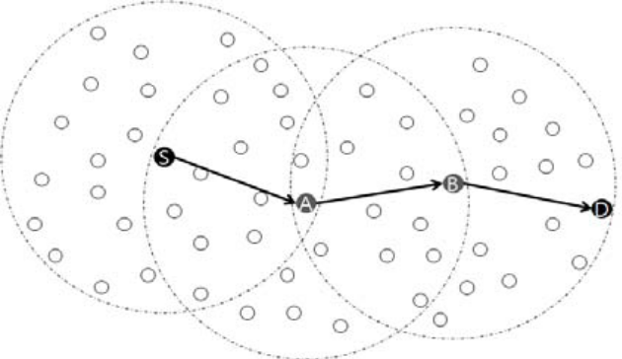

Fig. 1. An example of Original Greedy Forwarding.

Source node (S) selects node A that is the closest to destination node (D) in radio range.Node (A) selects node (B) to use same rules. Lastly, node (B) sends data packets to destination node (D)
When a transmission begins, the source node selects a candidate node for data transmission in neighbor nodes. A candidate node that is selected by the source node is the closest to the destination node using the local information. A candidate node receives the data packet perfectly and it sends ACK packets to the source node. Original Greedy Forwarding repeats this pattern, until data packets reach the destination node.
However, Original Greedy Forwarding assumes an ideal network model that always completes data transmission. If a candidate node has bad link quality, the retransmission would increase extremely. Therefore, the node energy is consumed wastefully in real WSNs. In real WSNs, we find a disconnected region in the source node’s radio range in which data transmission is impossible. Finally, the failure of data transmission incurs retransmission. This decreases network lifetime.

B. PRR×Distance Greedy Forwarding
Original Greedy Forwarding is unsuited to real WSNs due to link-quality. That is, there is a huge difference between realistic networks and ideal networks. PRR×Distance Greedy Forwarding makes up for the weaknesses in Original Greedy Forwarding. WSNs work in a real environment based on the link loss model in which we find the PRR concept (Packet Reception Rate). PRR is the ratio of data transmission success.
PRR×Distance Greedy Forwarding considers both sides of PRR and distance. That is, it strikes a balance between PRR and Distance_Improvement by multiplying the two values to solve problems of Original Greedy Forwarding and Absolute Reception-based Forwarding. In PRR×Distance Greedy Forwarding, we calculate Distance_Improvement to solve the problem of distance-hop energy tradeoff. Distance_Improvement is a normalized value of the distance between a neighbor node and destination node. It ranges from zero to one. Distance_Improvement is given by:

Distance_Improvement= 1- (d(nbr,dst)/d(crt,dst)) (1)

d(nbr,dst) is the distance between the destination node and a neighbor node. d(crt,dst) is the distance between the current node and the destination node and the current node.
We use the Packet Reception Rate (PRR) that presents the link quality between two nodes. It ranges from 0 to 1. It is given by:

PRR (d)=(1-0.5 e ^{–(} ^{γ (d)/2)*(1/0.64)} )^{16f-8l} (2)

d is the distance between two nodes, γ(d) is the signal to noise ratio for d, f is the length of a frame, and l is the length of a preamble. It considers various radio parameters in real WSNs.
In the connected region (from 0 to 8m), nodes can transmit data packets perfectly, because PRR is always 1. In the transitional region (from 8m to 35m), we observe various link qualities between two nodes. In the disconnected region (from 35m to radio range), we find no link.
In this method, the source node selects a candidate node that is the highest PRR×Distance_Improvement value in neighbour nodes. First, the source node selects the neighbour node, as a candidate node, whose location is within 1-hop distance for data packet forwarding. The distance of the neighbour nodes to the destination node is less than the distance between the source node and the destination node. Second, the source node sends data packets to the candidate node that has the highest PRR×Distance_Improvement value among neighbour nodes. Finally, it repeats these steps until data packets reach the destination node. PRR×Distance Greedy Forwarding complements excessive data retransmission of Original Greedy Forwarding. In addition, it complements the problem that is an extreme increase of hop-count in only PRR-based forwarding.

C. PBLE(Protocol that considers Both sides of Link-quality and Energy)
We consider the residual energy of the node to solve the problem of PRR×Distance Greedy Forwarding .Further, we balance energy and PRR×Distance_Improvement. Therefore, the network lifetime is improved compared to PRR×Distance Greedy Forwarding.Hence, we can achieve relatively efficient routing in WSNs by implementing PBLE routing.

III. PBLE FORWARDING STRATEGIES
PBLE is an efficient routing protocol that considers both sides of PRR and the Energy_level with the scheduling method. The method uses some factors that are on both sides of PRR, energy factor, and the distance within a 1-hop distance. Our selection method for candidate nodes is similar to the previous method. Also, we use reverse PRR and weight factors for efficient routing.

A. Assumption and Notation
PBLE assumes a general Wireless Sensor Network environment:
1) Every node knows the location of 1-hop neighbors and itself (using localization algorithms or GPS of WSNs).
2) Every node knows its PRR and the Energy_level and those of its 1-hop neighbors.
3) A source node knows the location of the destination node.

TABLE I
NOTATION
Description | Symbol
Packet Reception Rate of link from node A to B | PRR_{A→B}
Size of packet | S_{packet}
Distance between node A and B | d(A, B)
Node A’s residual energy | E_{A}(residual)

B .Design Concerns
1. Route Selection
Each node knows neighbour nodes within 1-hop radio range for efficient packet transmission. First, the source node calculates Distance_Improvement of the neighbour nodes using equation (1). Second, the source node eliminates some neighbour nodes by applying the blacklisting method of the energy factor and PRR factor. Third, the source node selects a candidate node that has the highest value of Expected Priority Value (EPV). EPV and blacklisting method is explained in the following subsections.

2. Expected Priority Value (EPV)
We use both sides of PRR and Energy_level with distance to balance the distance-hop energy trade-off and residual energy. Each node has the information of location, Energy_level and PRR of its neighbour nodes. The current forwarding node (source node) selects a candidate node from one of its neighbour nodes to take into account the size of the ACK message’s packet. A candidate node has the highest value of EPV. EPV is given by:

EPV=w₁x(MSL x Distance_Improvement)+w₂ x Energy_level (3)
We make use of the Modified Status of Link-quality (MSL), Energy_level, Distance_Improvement, and weight factors (w1 and w2). MSL is given by:

MSL= S_{data} x PRR_{src,nbr}/(S_{data}+S_{ACK}) + S_{ACK} x PRR_{nbr,src}/( S_{data} + S_{ACK}) (4)

MSL is the value that explains link quality between a source node and a neighbour node. We can describe the modified link quality of the route for data transmission based on the size of the data packet and ACK message packet. We apply two factors which decide the size of the packet (S_{data} and S_{ACK}) for various sizes of data packet. Additionally, we use both sides of PRR due to the asymmetric WSN.
We use the Energy_level of neighbor nodes to take into account the energy of a node. The Energy_level is a normalized value between 0 and 1. Energy_level is given by:

Energy_level= E_{A} (Residual)/ E_{A} (Initial) (5)

E_{A} (initial) is the initial energy of node (A). E_{A} (residual) is the residual energy of node (A).
w1 and w2 are weight factors. Weight factors are defined by the Energy_level of neighbour nodes. If neighbour nodes in WSNs have sufficient energy to send or receive data packets, we do not need to consider the relative energy factor in data transmission. Therefore, we can send data packets focusing on link quality and distance, such as Distance_Improvement and MSL. Weight factors are decided within 1-hop, locally. We calculate weight factors from the average Energy_level of neighbor nodes. Weight factors are given by:
w₁= (Σ_{i=1 to n} Energy_level_{nbr(i)})/n (6)
w₁+ w₂=1 (7)
In (6), Energy_level_{nbr(i)} is calculated by (5) about neighbour nodes.

3. Blacklisting Strategies
We use the blacklisting method in every data transmission process for reliable data transmission. We found the blacklisting method based on PRR value in PRR×Distance
Greedy Forwarding. In PBLE, we also apply the blacklisting method based on Energy_level.
PRR-based Blacklisting: we use both side of PRR value for the blacklisting method based on PRR, because we assume an asymmetric WSN environment. We use the value of the
PRR_{threshold} in each data transmission. If the value in both sides of PRR is less than the PRR_{threshold}, we will omit the neighbour node when selecting a candidate node.
Energy-based Blacklisting: we use the value of the Energy_{threshold} to apply Energy-based blacklisting. The node should have sufficient energy for appropriate data transmission of the node. The current node omits neighbour nodes from the candidate node list that have a lower Energy_level than the Energy_{threshold}.

C. Data transmission
The current node eliminates some of the neighbour nodes using the blacklisting method in data transmission. Then, the current node sends data packets to a candidate node that has the highest EPV of the neighbour nodes (see Fig. 2). If the current node does not receive the ACK message from the candidate node perfectly, the current node should retransmit. Data delivery will fail, if the number of retransmission times exceeds ARQ (Automatic Repeat reQuest). ARQ is the automatic repeat request. Each node updates the Energy_level of neighbour nodes at the end of each transmission. Each node repeats these steps until the destination node receives data packets.

IV. EXPERIMENTAL RESULTS
In this section, we use C++ to simulate and evaluate the performance of PBLE and compare it to PRR×Distance Greedy Forwarding.

A. Assumptions for simulation:
1) In the simulation, the data packet size is 100 bytes and the
size of the ACK packet is 11 bytes.
2) The energy consumption of data transmission is 1762.5 μJ and the energy consumption of ACK transmission is 193.875 μJ.
3) Initial battery energy is considered to be 11.45 kJ.
4) All the neighbour nodes are equidistant from the current node.
5) There is no packet transmission loss (ideal channel).

B. Network model
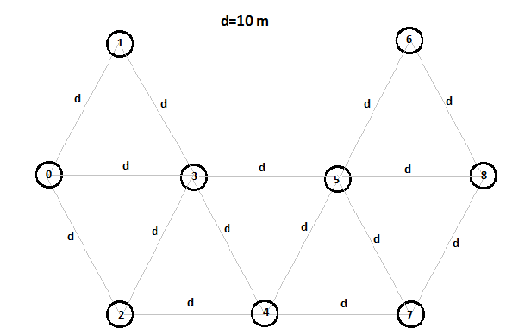
Fig. 2. Network Model for Simulation

C. SIMULATION RESULTS
For the model considered, we measure the variation in the network energy for the transmission of 100 packets of data using both PBLE and PRRxDistance_Improvement
Protocols for routing. The results are as in the graph shown in Fig. 3.
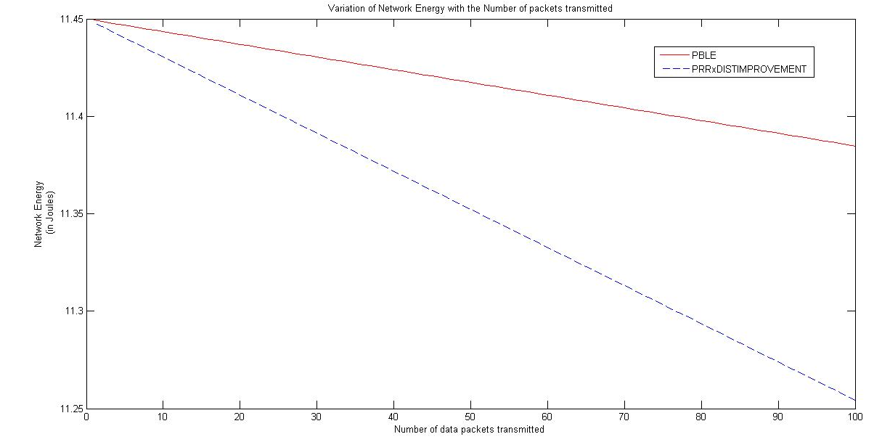
Fig. 3. Variation of network energy with number of packets transmitted

For a given pair of source and destination node, PRRxDistance_Improvement protocol considers a single path for data transmission. While the PBLE protocol considers various paths for data transmission that is decided by the EPV of the neighbouring nodes. Hence the average energy utilized for a particular path is less for PBLE, improving the lifetime of the path and hence the network.

V. CONCLUSION
Energy-efficient transmission is an important and fundamental issue in real wireless sensor networks. Previous existing routing methods had problems in real WSNs. Here we study, a routing method, PBLE. PBLE uses EPV that considers the asymmetry of wireless links and calculates the Energy_level, PRR and local information of the node. PBLE improves data transmission compared to previous schemes. PBLE achieves higher performance in terms of Energy_level and considers the asymmetric environment from an increased network lifetime. In addition, the node-scheduling method contributes to prolong the network lifetime. That is, we achieve superior results to previous schemes in delivery rate, lifetime rate and relative retransmission rate for various WSN environments. In the future, we will extend our study by applying it to a Multi-Hoping Wireless sensor network. PBLE can be improved for mobile sensors with wireless links.

